APPENDIX
Supplemental Tables/Figures

Economic Burden of Cardiovascular Events in Patients with Chronic Lymphocytic Leukemia or Small Lymphocytic Lymphoma in the First Year After Initiating Treatment with a Novel Agent

Elisabetta Malangone-Monaco, DrPH; Kellie Ryan, MPH; Elizabeth H. Marchlewicz, PhD, MPH, RD; Joyce Lo, PharmD; Scott Huntington, MD, MPH

This Appendix has not been edited and is provided as supplemental materials for this article, which was published in the Journal of Hematology Oncology Pharmacy in February 2023.

Table 1. Diagnosis Codes used to Define Cardiovascular (CV) Events¹

CV Event | ICD-9-CM Diagnosis Codes | ICD-10-CM Diagnosis Codes
Cardiomyopathy | 425.8, 425.9 | I42.x, I43
Conduction Disorder | 426.xx | I44.x, I45.x
Heart Failure | 428.x, 402.01, 402.11, 402.91, 404.01, 404.03, 404.11, 404.13, 404.91, 404.93 | I40.1, I50.2x, I50.3x, I50.4x, I50.8x, I50.9, I11.0, I13.0, I13.2
Hypertension | 401.x, 402.00, 402.10, 402.90, 403.x, 404.00, 404.02, 404.10, 404.12, 404.90, 404.92, 405.x | I10, I11.9, I12.x, I13.1x, I15.x, I16.x, R03.0
Myocardial Infarction | 410.xx | I21.xx, I22.x
Ventricular Arrythmia | 427.1, 427.2, 427.41, 427.42 | I47.0, I47.2, I47.9, I49.01, I49.02
Supraventricular Arrythmia | 427.0, 427.31, 427.32 | I47.1, I47.9, I48.x

¹CV events were identified by at least one inpatient or outpatient non-ruleout claim with a diagnosis for the CV event. Non-ruleout claims are those for a professional encounter, not a laboratory test or imagining study used to diagnose a condition.
Table 2. Unadjusted healthcare resource utilization and costs during the follow-up period
Service or Cost | Variable-Length Follow-Up (Annualized)¹ |  |  | Variable-Length Follow-Up (PPPM)²
 | CV Cohort  N=522 | NoCV Cohort  N=1,364 | P-value | Pre-CV Event  N=522 |  | Post-CV Event  N=522 |  | P-value
Healthcare Service
Any hospital admission, N (%) | 263 (50.4%) | 301 (22.1%) | <0.001 | 68 (13.0%) | 230 (44.1%) |  | <0.001
Number of admissions, mean (SD) | 1.35 (2.10) | 0.55 (1.54) | <0.001 | 0.05 (0.15) | 0.16 (0.28) |  | <0.001
Length of stay, days, mean (SD) | 18.70 (25.38) | 16.23 (29.68) | 0.093 | 1.95 (2.47) | 2.61 (3.67) |  | <0.001
Outpatient services, N (%) | 522 (100.0%) | 1356 (99.4%) | 0.116 | 472 (90.4%) | 522 (100.0%) |  | <0.001
Emergency Room (ER) visits, N (%) | 254 (48.7%) | 387 (28.4%) | <0.001 | 97 (18.6%) | 207 (39.7%) |  | <0.001
Number of visits, mean (SD) | 1.59 (2.69) | 0.79 (2.14) | <0.001 | 0.09 (0.27) | 0.14 (0.26) |  | 0.003
Physician office visits, N (%) | 512 (98.1%) | 1,333 (97.7%) | 0.634 | 442 (84.7%) | 473 (90.6%) |  | 0.004
Number of visits, mean (SD) | 24.80 (14.46) | 20.93 (12.95) | <0.001 | 1.89 (1.56) | 1.93 (1.35) |  | 0.676
Other outpatient services, N (%) | 522 (100.0%) | 1,347 (98.8%) | 0.005 | 455 (87.2%) | 517 (99.0%) |  | <0.001
Number of visits, mean (SD) | 62.46 (71.52) | 39.50 (37.41) | <0.001 | 3.74 (4.65) | 5.37 (7.01) |  | 0.002
Outpatient pharmacy, N (%) | 522 (100.0%) | 1,364 (100.0%) | 1.000 | 514 (98.5%) | 488 (93.5%) |  | <0.001
Number of prescriptions, mean (SD) | 50.94 (28.37) | 43.02 (26.62) | <0.001 | 3.91 (2.64) | 4.20 (2.45) |  | 0.137
Novel agent therapy, N (%) | 522 (100.0%) | 1,364 (100.0%) | 1.000 | 514 (98.5%) | 382 (73.2%) |  | <0.001
Number of prescriptions, mean (SD) | 9.66 (4.15) | 10.82 (4.31) | <0.001 | 1.06 (0.30) | 0.59 (0.45) |  | <0.001
Healthcare Costs
Any hospital admission, mean (SD) | $51,865 ($137,049) | $24,241 ($124,732) | <0.001 | $1,259 ($6,171) | $7,190 ($21,560) |  | <0.001
Any outpatient service, mean (SD) | $47,646 ($81,826) | $33,192 ($68,035) | <0.001 | $2,934 ($6,759) | $4,155 ($7,631) |  | 0.006
ER visits, mean (SD) | $2,580 ($8,250) | $1,191 ($5,282) | <0.001 | $142 ($649) | $229 ($870) |  | 0.070
Physician office visits, mean (SD) | $3,366 ($2,536) | $2,763 ($2,307) | <0.001 | $266 ($290) | $267 ($235) |  | 0.942
Other outpatient services, mean (SD) | $41,700 ($76,586) | $29,238 ($66,085) | <0.001 | $2,526 ($6,526) | $3,659 ($7,184) |  | 0.008
Outpatient pharmacy, mean (SD) | $117,062 ($75,502) | $126,622 ($57,761) | 0.003 | $12,425 ($5,889) | $7,186 ($5,866) |  | <0.001
Novel agent therapy, mean (SD) | $110,015 ($70,682) | $121,558 ($55,277) | <0.001 | $11,932 ($5,313) | $6,667 ($5,768) |  | <0.001
Total Healthcare Costs, mean (SD) | $216,573 ($181,588) | $184,055 ($158,781) | <0.001 | $16,619 ($11,633) | $18,531 ($23,278) |  | 0.093
¹Healthcare utilization in the variable-length follow-up period was reported as annualized totals, comparing the CV cohort to the NoCV cohort.
²Healthcare utilization in the variable-length pre-CV and post-CV event periods were reported as per-patient-per-month (PPPM), comparing time periods for patients in the CV cohort.
Figure 1. Study Time Periods

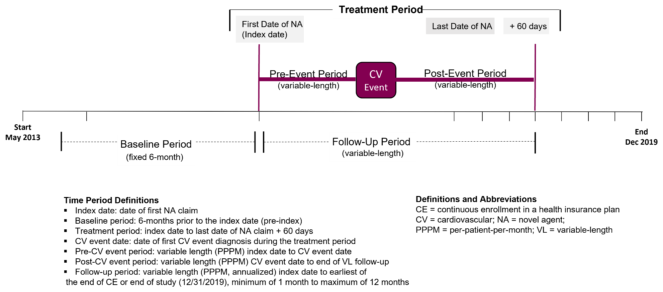

Figure 2. Total all-cause healthcare costs in 30-day months surrounding the CV event date among CLL/SLL patients in the CV cohort¹

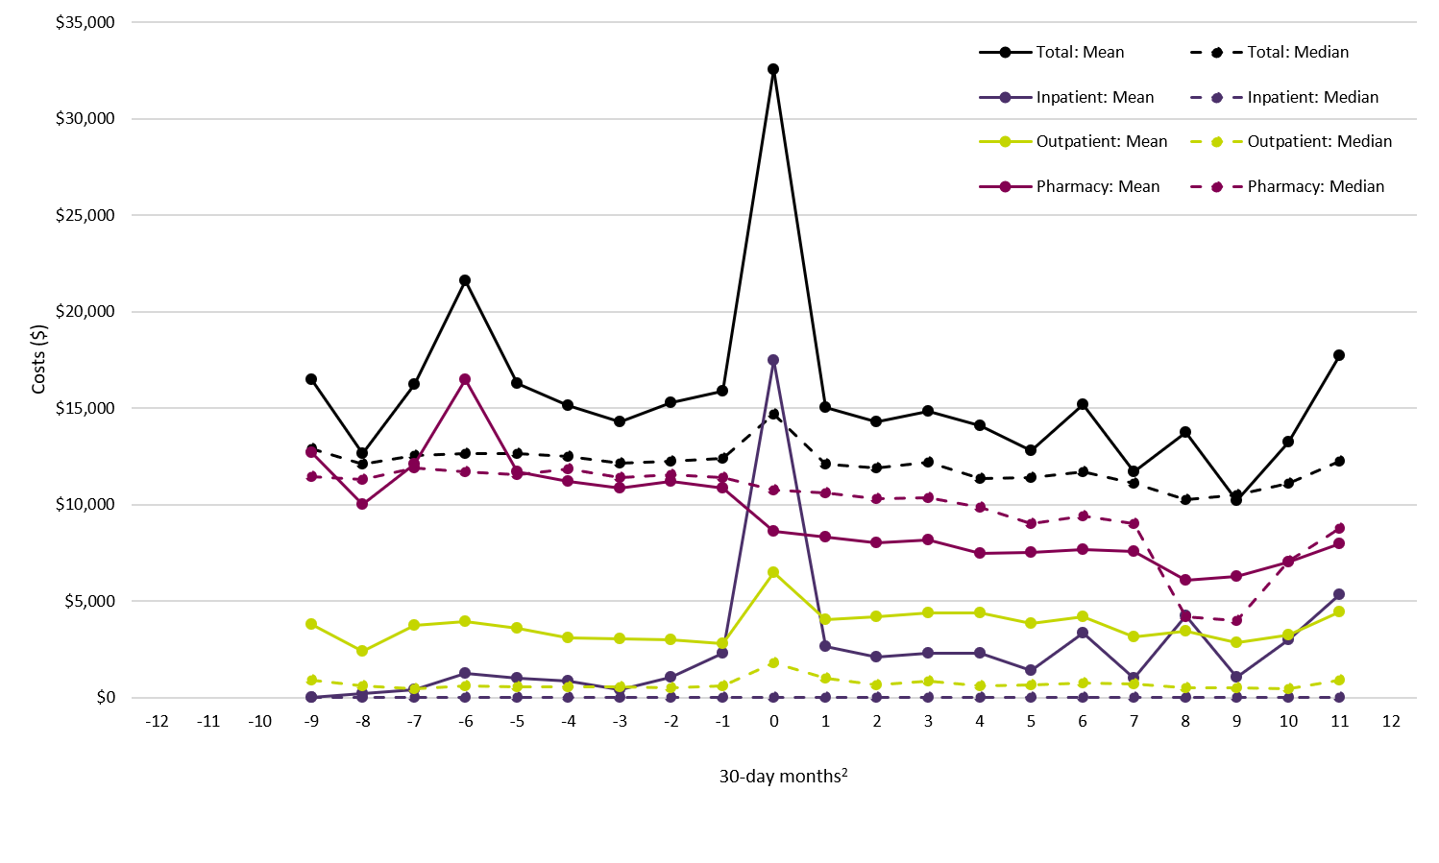
¹ This analysis was limited to patients in the CV Cohort (N=522); costs were reported as total cost measured in each 30-day period. Patients had to have continuous enrollment for the full 30-day period to be included in that period; no patients had continuous enrollment for the full 30-day periods 10-12 months prior to the CV event date or 12 months after the CV event date.
² The CV event date is centered in period 0; period 0 includes 15 days prior to the CV event date through 14 days after the CV event date.

